# TikTok Video Downloader: No Watermark

**INTRODUCTION**

TikTok has taken the world by storm, offering users a platform to create and share short, engaging videos. However, many TikTok users wish to download their favorite videos without the watermark for various reasons, such as creating compilations or personal archives. In this article, we'll explore the world of TikTok video downloaders that allow you to obtain these videos without the watermark. We'll cover what TikTok is, its immense popularity, the need for downloading videos, the role of TikTok video downloaders, the issues related to watermarks, the advantages of watermark-free videos, and the legal considerations surrounding this practice. Additionally, we'll guide you through how to use a TikTok video downloader, present some popular options, discuss safety and security concerns, and provide user reviews and helpful tips and tricks. Let's dive in!



**What is TikTok?**

Launched in 2016, it has quickly become one of the most popular apps worldwide, boasting over a billion users. TikTok allows its users to create, edit, and share videos set to music and offers various features like filters, effects, and a vast library of soundtracks.

**The Popularity of TikTok**

TikTok's success can be attributed to its user-friendly interface and the ability to create viral content. The platform encourages creativity and offers a space for self-expression, making it especially appealing to a younger demographic.

**The Need for Downloading**

Users often want to download TikTok videos for various reasons, such as saving personal memories, creating compilations, or sharing content outside the app. However, the watermark, which includes the TikTok logo and username, is automatically added to downloaded videos, making them less appealing for these purposes.

**TikTok Video Downloaders**

[**TikTok video downloaders**](https://ttmate.io/) are software or online tools that allow users to download TikTok videos without the watermark. These tools enable you to keep your favorite videos in their original quality and without any added branding.



**The Problem with Watermarks**

Watermarks can be distracting and unattractive, particularly if you intend to use the downloaded videos for creative or promotional purposes. They also limit the freedom to share videos on other platforms.

**Benefits of No Watermark**

Downloading TikTok videos without watermarks offers you greater flexibility and creative control. You can edit and share these videos without any restrictions, making them more suitable for personal or promotional use.

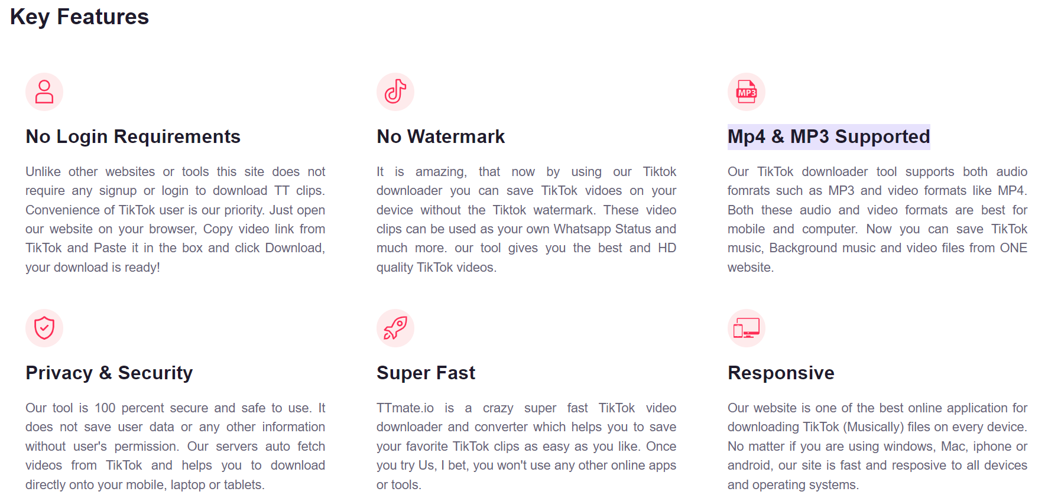

**The Legal Implications**

It's important to note that downloading TikTok videos without permission may raise legal concerns. The videos on TikTok are created and uploaded by users who may have rights over their content. Downloading and sharing videos without proper authorization could infringe upon these rights, potentially leading to legal issues.

**How to use a Downloader**

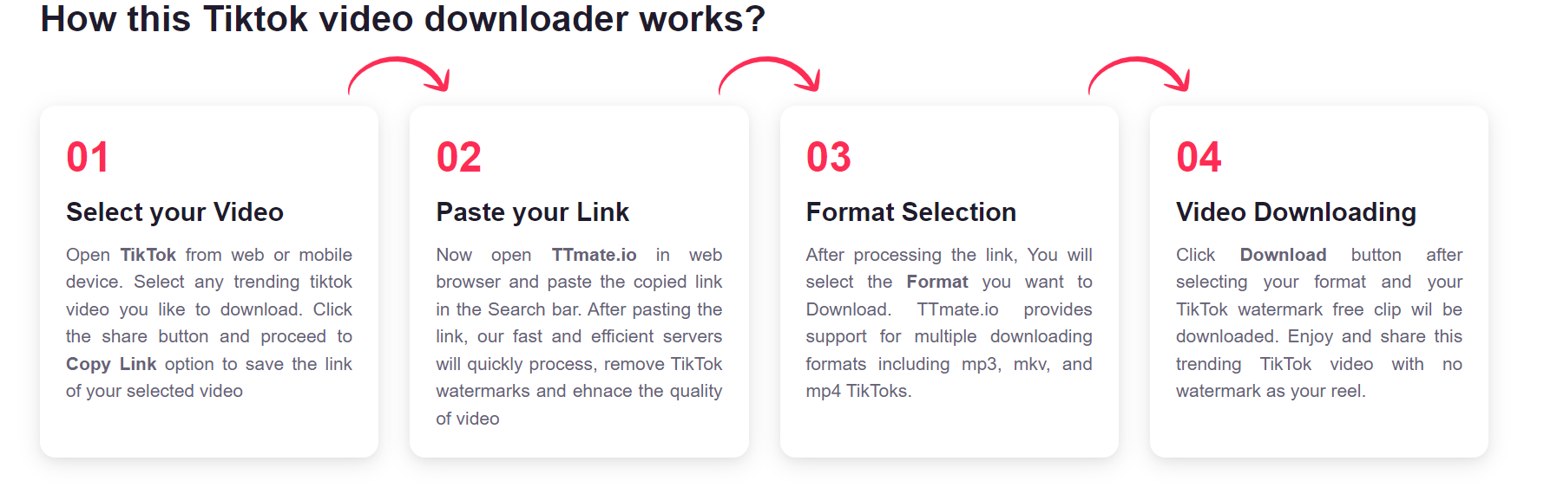

Using a TikTok video downloader is simple. You need to find a reputable downloader, paste the video's URL, and choose the download options. Most downloaders offer choices regarding video quality and whether you want to include the video's description or captions.

**Popular Downloaders**

There are several TikTok video downloaders available online, each with its own features and advantages. Some popular options include [**TT Downloader**](https://ttmate.io/), 4K Video Downloader, and **TT Mate downloader**.

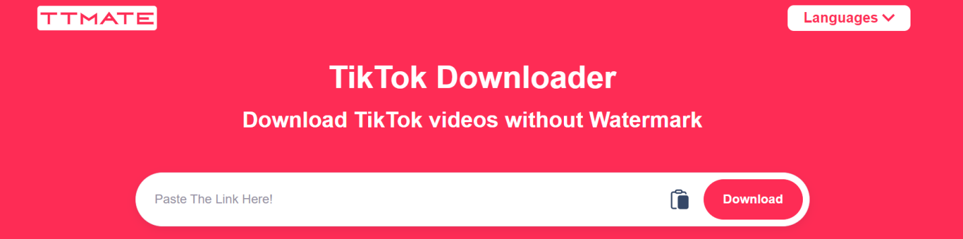

**Safety and Security**

When using TikTok video downloaders, it's crucial to ensure the safety and security of your device. Only use trusted downloaders and avoid downloading from unverified sources to protect your system from potential malware or viruses.

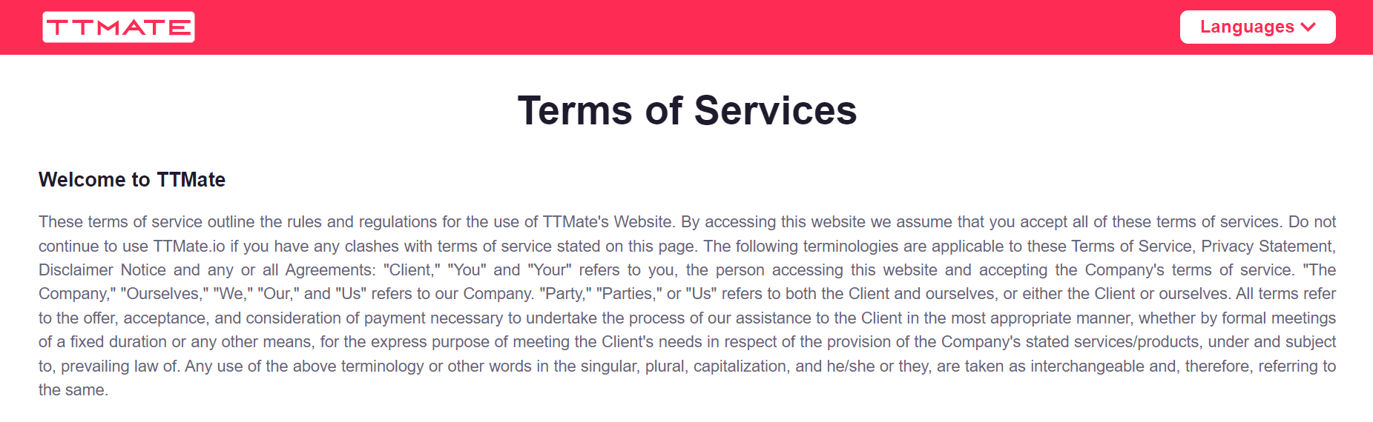

**User Reviews**

User reviews are a valuable source of information when choosing a TikTok video downloader. Reading about the experiences of other users can help you make an informed decision and select the best tool for your needs.

**Tips and Tricks**

Here are some tips to make your TikTok video downloading experience smoother and more efficient:

* Always check the terms of use and copyright policies before downloading and sharing TikTok videos.
* Respect the original content creators by providing proper credit if you use their videos.
* Keep your video downloader and antivirus software up to date to ensure safety.

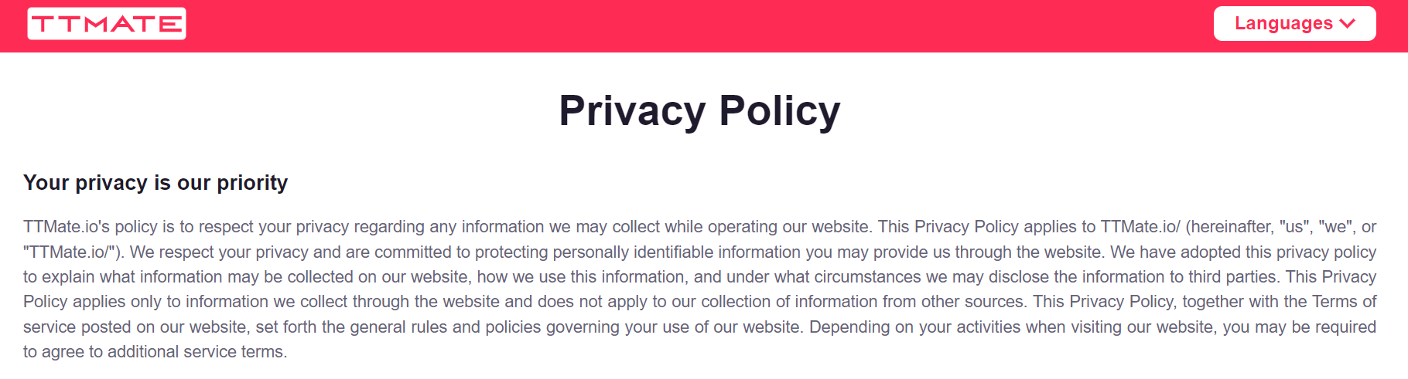

**Conclusion**

[**TikTok video downloaders without watermarks**](https://ttmate.io/) provide a convenient way to preserve and share your favorite TikTok videos. While these tools offer benefits in terms of creative freedom, it's important to be aware of the legal implications and use them responsibly. By following our guide on how to use these downloaders, considering safety and security measures, and respecting copyright, you can enjoy a seamless experience with TikTok video downloads.

**FAQs**

**1. It is legal to download TikTok without watermark?**

Downloading TikTok videos without permission may raise legal concerns, as the content is created by users who may have rights over their videos. It's essential to respect copyright and use these videos responsibly.

**2. What are some popular TikTok video downloaders?**

Some popular TikTok video downloaders include SnapDownloader, 4K Video Downloader, and VidMate. Be sure to choose a trusted and reputable source for downloading.

**3. How can I ensure the safety and security of my device while using TikTok video downloaders?**

To ensure safety and security, only use trusted downloaders from reputable sources. Avoid downloading from unverified sources to protect your device from potential malware or viruses.

**4. Can I edit downloaded TikTok video without watermarks for personal or promotional use?**

Yes, downloading TikTok videos without watermarks allows you greater flexibility and creative control. You can edit and share these videos without any restrictions, making them suitable for personal or promotional use.

**5. What are some essential tips for using TikTok video downloaders responsibility?**

Always check the terms of use and copyright policies before downloading and sharing TikTok videos. Respect the original content creators by providing proper credit if you use their videos. Keep your video downloader and antivirus software up to date to ensure safety.